**PROBLEM#02**

**Q** :Write a program which prints Marks Report and calculates(Obtain marks , Percentage , Grade , GPA) according to marks of each subjects input by user.

**SOURCE CODE:**

#include <stdio.h>

int main(void){

//All the variables for subjects..

float eng;

float cal;

float pst;

float ict;

float disc;

float pf;

float obt;

float per;

// heading

printf("\n\n\t********\tENTER MARKS OF ALL SUBJECTS\t********\t");

// here we enter marks of all subjects

printf(" \n\n ENTER SUBJECTS 1 MARKS [ENGLISH] \n ");

scanf("%f",&eng);//take input of subject marks

printf(" \n ENTER SUBJECTS 2 MARKS [CALCULAS]\n ");

scanf("%f",&cal);//take input of subject marks

printf(" \n ENTER SUBJECTS 3 MARKS [PAKISTAN STUDIES]\n ");

scanf("%f",&pst);//take input of subject marks

printf(" \n ENTER SUBJECTS 4 MARKS [ICT]\n ");

scanf("%f",&ict);//take input of subject marks

printf(" \n ENTER SUBJECTS 5 MARKS [DISCRETE STRUCTURE] \n ");

scanf("%f",&disc);//take input of subject marks

printf(" \n ENTER SUBJECTS 6 MARKS [PROGRAMMING FUNDAMENTAL]\n ");

scanf("%f",&pf);//take input of subject marks

// start of marks report

//heading

printf("\n\t********\tMARKS REPORT\t********\t");

// here we calculate obtain marks

obt = eng + cal+ ict + pst + disc + pf;

printf("\n\n TOTAL MARKS\t = 600");

printf(" \n OBTAIN MARKS \t =%.0f ",obt);

//here we calculate percentage%

float total = 600;

per = (obt/600)*100;

printf(" \n PERCENTAGE IS \t =%.2f ",per);

// here is a code for grades and GPA

//if percentage is greater than or equal to 90

if (per>= 90){

printf("\n GRADE IS \t =A+");

printf("\n GPA IS \t =4.0");

}

//if percentage is greater than or equals to 85 or less than or equals to 89

else if (per>= 85 && per<=89){

printf("\n GRADE IS \t =A");

printf("\n GPA IS \t =4.0");

}

//if percentage is greater than or equals to 80 or less than or equals to 84

else if (per>= 80 && per<=84){

printf("\n GRADE IS \t =A-");

printf("\n GPA IS \t =3.8");

}

//if percentage is greater than or equals to 75 or less than or equals to 79

else if (per>= 75 && per<=79){

printf("\n GRADE IS \t =B+");

printf("\n GPA IS \t =3.4");

}

//if percentage is greater than or equals to 71 or less than or equals to 74

else if (per>= 71 && per<=74){

printf("\n GRADE IS \t =B");

printf("\n GPA IS \t =3.0");

}

//if percentage is greater than or equals to 68 or less than or equals to 70

else if (per>= 68 && per<=70){

printf("\n GRADE IS \t =B-");

printf("\n GPA IS \t =2.8");

}

//if percentage is greater than or equals to 64 or less than or equals to 67

else if (per>= 64 && per<=67){

printf("\n GRADE IS \t =C+");

printf("\n GPA IS \t =2.4");

}

//if percentage is greater than or equals to 61 or less than or equals to 63

else if (per>= 61 && per<=63){

printf("\n GRADE IS \t =C");

printf("\n GPA IS \t =2.0");

}

//if percentage is greater than or equals to 57 or less than or equals to 60

else if (per>= 57 && per<=60){

printf("\n GRADE IS \t =C-");

printf("\n GPA IS \t =1.8");

}

//if percentage is greater than or equals to 53 or less than or equals to 56

else if (per>= 53 && per<=56){

printf("\n GRADE IS \t =D+");

printf("\n GPA IS \t =1.4");

}

//if percentage is greater than or equals to 50 or less than or equals to 52

else if (per>= 50 && per<=52){

printf("\n GRADE IS \t =D");

printf("\n GPA IS \t =1.0");

}

// if percentage is less than 50

else if (per<50){

printf("\n GRADE IS \t =FAIL");

}

//end of code

getche();

}

**OUTPUT:**

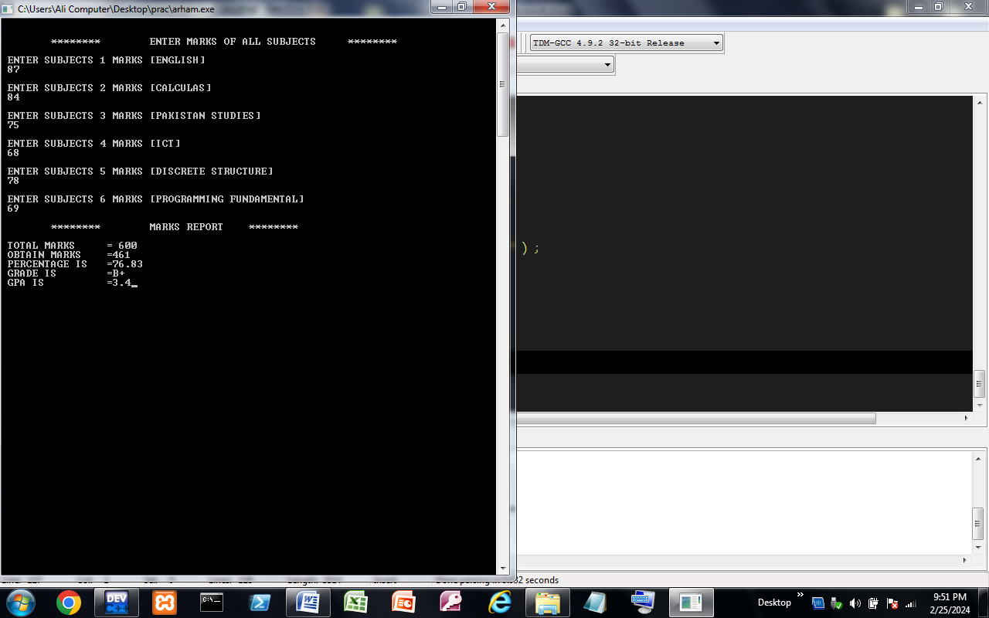

Made By :

***Kashan Ali Khan(BS-SE)***